**Lost opportunity for the City of Stirling**

Work on the Stephenson Avenue Extension will start soon. Some times ago I attended the first Stirling City Centre Alliance meetings and others that follows. Years have passed and unfortunately the great futuristic vision from the first meetings have vanished.

See link for more information of **Station Precinct** development plan (<https://yoursay.stirling.wa.gov.au/stirling-city-centre-amendment>)

Unfortunately, a freeway bridge, which is not shown in Station Precinct Block Plan, which was a major consideration at the start of the Stirling City Festival [Letter 1](https://www.boeingconsult.com/Letter-1(24Jul09)_1-4.pdf) & [Letter-2](https://www.boeingconsult.com/Letter-2Precinct2P1-1a.pdf)).

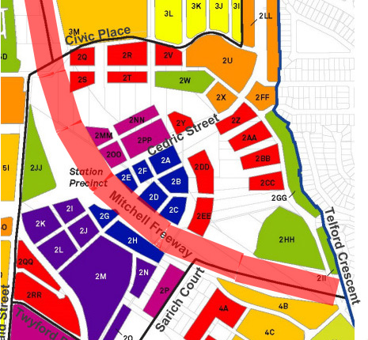At present the freeway segregates the development area and there is no vibrant town centre for the community. It’s well known, that people who live near the freeway face pollution increasing harm to health and wellbeing.

There are two question:

1. Is there any provision made to protect people from adverse effect living near the freeway?
2. Why is a land bridge idea not incorporated?

Some countries that have utilising space above the freeway:  
Germany [Berlin](https://www.boeingconsult.com/WilmersdorfSchlangenbergerStyra%C3%9Fe.jpg)  
USA 1[Seattle](https://www.boeingconsult.com/BigLidSeattle.jpg) & 2[Dallas](https://www.boeingconsult.com/DallasKlydeWarrenParkFreewayUnder.jpg)  
Japan [Osaka](https://www.boeingconsult.com/Building_penetrated_by_expressway_OSAKA_JPN.jpg)